1. Long method:
   1. Location: validations in saveItem() or saveContact() of the following classes AddItemActivity, EditItemActivity, AddContactActivity, EditContactActivity.
   2. The code smell:

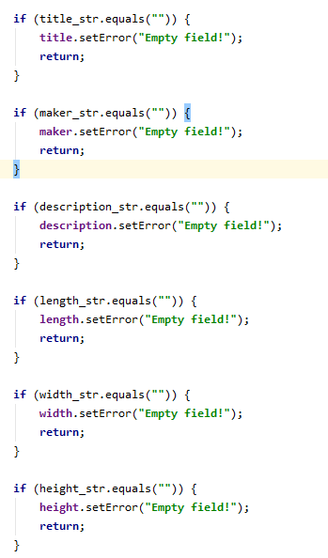

* 1. Potential problem: this makes the method longer and more complicated to debug if any mistakes.
  2. Solution: create a separate validateInput() method to address this code smell.

1. Duplicated code:
   1. Location: validations in saveItem() or saveContact() of the following classes AddItemActivity, EditItemActivity, AddContactActivity, EditContactActivity.
   2. The code smell:



* 1. Potential problems: need to copy the same portion of code to many classes. The code is not clean and redundant.
  2. Solution: create a separate class to handle Input validation.